This page contains an abridged transcription of Frank's very own handwritten account of the long, strange trip that brought him to where he is today. This is by no means a comprehensive history of the band in its current form, but rather a glimpse into the man, the myth, the legend that is "Famous" Frank Ward.

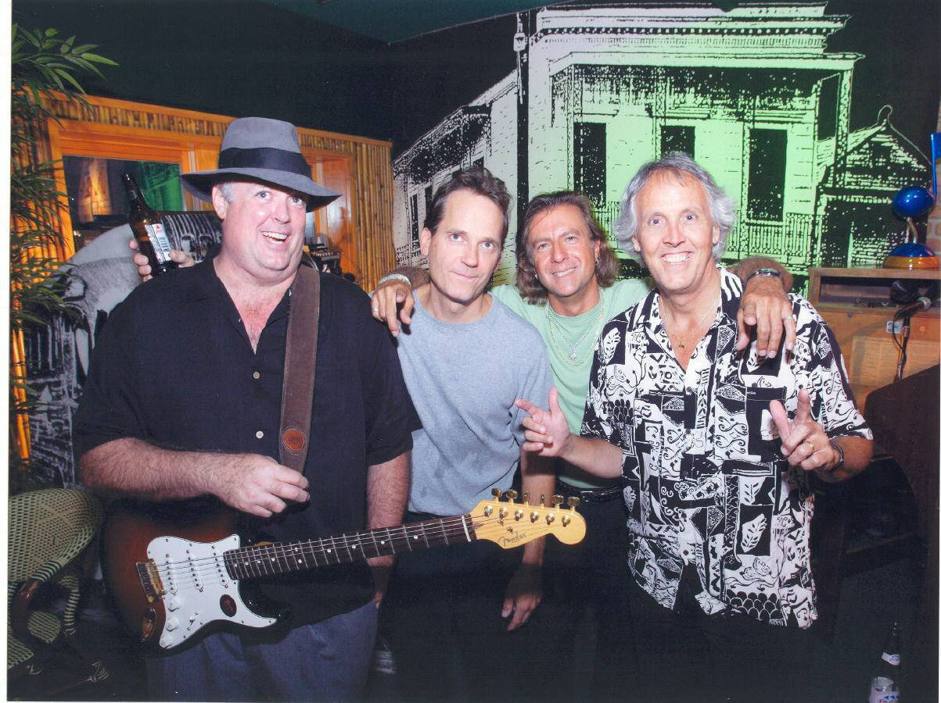

The Nucklebusters Blues Band Pic Circa 2005
I started at age 20, when workmates at the JC Penney Auto Center started a band just for fun. They needed a singer, and I was willing to give it a try. We played a party at a private home, and I liked it. I enjoyed the crowd, and playing music with my friends. I felt uncomfortable with my hands having nothing to do while I sang, so I learned just enough guitar to hold one in my hands while I sang (a la Elvis). My roommate was a guitarist, and one of my friends loaned me an acoustic guitar. They both showed me some chords (Beatles, etc) and I practiced while watching TV. That band, which was never even named, soon broke up. I continued to practice, but mainly concentrated on my race car.
I had a very good friend from the age of 13-16 named Curt Aldstadt, who was quite the piano player and guitarist. He always tried to get me into guitar playing and listening to music other than what I was used to. He was into Hendrix, Trower and Clapton. I liked music a lot, but the radio was fine - remember, in 1969, the radio was pretty good! Curt knew I had some music background as a trumpet player (from age 12-16). My other best friend from that era was named John Reed. He played trumpet, as well as many other instruments. He was a true prodigy and hanging with him got me playing at least two hours a day. I played so much I got very good & burned out. At that point, I had to go to symphonic orchestra or marching band. I had no interest in either, so I quit. Several months later, the high school band director shot himself. Conicidence? So back to Curt: While visiting from college in 1977, Curt discovered that I had a warehouse for my race car. He had a guitar amp way too loud (& big) for his parents' apartment. He moved the amp to my shop, and we played through it together. A drummer named Tim Preisenger was driving by and heard us playing. He asked if he could go get his drum set. He returned with drums and a bass player friend of his named Tom Uellner. Tim and Curt were good players and Tom and I were beginners, but it worked ok.
Curt went back to school leaving us as a 3 piece. We picked up a singer (whose name escapes me) and got our first gig at a place in Deerfield named "Balls" (for the pinball machines). The singer disappeared and we went on as a 3 piece band named Rampage. The previous lineup was named "Buzzard Puke." The 3 piece format forced immediate improvement on my part. We all got along so well we practiced constantly. Our main gig was at Tradewinds Park. Our friends would rent a pavillion and we would play (loud!). Tim and I started writing songs and he started singing his lyrics to my music. The he wanted to sing everything - Stones, Sabbath, etc. We drank bourbon (George Dickel or Rebel Yell), often in the morning. These events were well-attended and out of control. Still 20 years later, live music is not allowed at the park. This should be known as the "Rampage Rule."
Tom, Tim and I went into a recording studio and did 7 original songs. A good project for the first try. 4 electric and 3 acoustic songs, with Tim singing 6 of them. This was in 1979. Tim and Tom moved to Massachussets. I joined a 4 piece band and met bass player Brian Gibson. That band broke up. Steve Mandarino (my current business partner) joined Brian and me on drums, and we played as a 3 piece until 1984. I played around a bit, but gave up on music around 1986.
1987 - I was still in contact with Brian, and asked if he would like to start a blues band. My best material from the rock & roll days seemed to be George Thorogood/Johnny Winter stuff. My favorite bands, The Who, Stones and Beatles all paid tribute to the blues, so why not? I ran an ad in Rag Magazine for a drummer, and was called by Vince Veldhuis. Nice guy, good blues drummer, and he had a P.A. system, a truck, and a willingness to teach me blues. We were joined by guitarist Doug Ellman. A stockbroker by trade and he fit the mold. He named us "The Elmo Batman Blues Band" and proceeded to become a pain in my ass. - P.S. - We stunk! We went 3 piece and practiced in a photography studio in a basement in downtown Lake Worth.We were joined by Vince's rommate Marty Gunther on harmonica. He schooled me in blues until a hearing problem forced him from music in 1989. Our first gig came at Hector's Heck Of A Burger in Delray. I played on the pool team there and knew the owner, Dick. He was talked into trying a blues band on Thursday nights by Mike Cotton, who would go into a place like Hector's and create a gig at a club with no prior music experience. Brian and I went in on a Thursday to show support. Eight people in the place, including band and staff, told me this wasn't working. Cotton's band (Shades Of Blue) needed 2 weeks off, so Dick asked my band to fill in. I told him we weren't ready, but I guess he figured he had nothing to lose. Marty and I had a lot of people who wanted to see us return to playing after years of inactivity. Our first night was standing room only, about 220 people. Next week half of that, and so on. We played there every week for a few months, and foolishly used the money to buy band equipment, and bail Brian out of jail. Brian was not suited to the blues and his legal and transportation ills led to his release.
He was replaced by George Romano. His rock/funk style took us in a different direction, and Vince was then replaced by Greg Sczcesniak. During this time as a three piece band, I ran an ad in Rag Magazine for a 4th piece - harp, guitar, sax, piano, etc. John Harris (of the Fabulous Fleetwoods) was nice enough to help us out as a 4th piece sometimes, but the Fleetwoods were very popular, and he lacked time. He was also a well-respected seasoned player, which gave us more credibility than we deserved.
Answering my ad while we were playing in 1991 at Florida Atlantic University was a just-moved-to-town Johnny Charles Marino. He joined the band until he moved back to Massachussets in 1994. During that time, drummer Greg worked with a show band, and was often absent. This gave me the opportunity to work with some very nice and talented drummers as fill-ins.
Greg left the band in 1995, as did George, replaced by Tom DeQuatro and Joe Coleman. When Johnny moved to Massachussets in 1994, he was replaced by committee - Bob Freeman on Hammond organ, John Harris when available, and Jerry Tartone on organ.
Johnny moved back to Florida in late 1995. At that point we had a real blues band. Tom on drums had been with Duke Robillard in the 80's and is a good friend and mentor. He moved to Rhode Island in 1997. Joe Coleman was on bass for 1996, and was replaced by Sheldon Voss in 1997. Tim Kuchta (drums) started in 1996, and Rick Geragi, who is Tim's backup, has been with us since 1994. Rick's references include playing with Carole King, Robbie Neville, and Delaney & Bonnie. Rounding out the current lineup, Jason Ricci came aboard in 1999.

